Hapeville Charter Schools Vision Statement

The vision of Hapeville Charter Schools is to establish a school-wide environment that will transform students into productive individuals working together to enrich their lives and lead future generations.
Hapeville Charter Middle School Mission Statement
The mission of Hapeville Charter Middle School is to prepare each student in a safe and caring learning environment for successful transition to high school.

Hapeville Charter Middle School 2018-2019 School-wide Goals
In accordance with the statements of vision and mission, the school-wide goals reflect three focus areas and have been developed to give direction to Hapeville Charter Middle School. The focus areas include Culture & Climate; Professional Growth; and Curriculum, Instruction, and Assessment. Hapeville Charter MS will complete specific actions to support students, teachers, and parents.
Goal | Area of Focus
- To improve students’ academic achievement in math, reading, science, and social studies as reflected on the GMAS | Professional Growth  Curriculum, Instruction, & Assessment
- To improve the teacher retention rate by retaining at least 75% of the staff for the 2019-2020 school-year | Professional Growth  Culture & Climate
- To decrease the percentage of students receiving ISS and/or OSS | Culture & Climate  Curriculum, Instruction, & Assessment

Goal # 1

To improve students’ academic achievement in math, reading, science, and social studies as
reflected on the GMAS

Overview of Data
The data charts displayed below reflect the results of the FastBridge screening assessments administered in August. The purpose of the FastBridge screener is to identify students who may benefit from additional instructional support in reading and/or mathematics. HCMS used the data from the screener to determine which students would participate in our Remedial Education Program (REP) courses, teacher-led tutorials and school-based after school remediation. As of today, there are at least two REP math courses and two REP reading courses at each grade level to support struggling learners. To further assist this group of students, teachers have begun offering afterschool tutorial and HCMS will implement its school-based afterschool remediation program starting in January. Teachers are being trained in the area of differentiated instruction and will provide more targeted instruction to students that fall below level. We will monitor students’ progress throughout the school-year and administer two additional FastBridge assessments to determine growth.

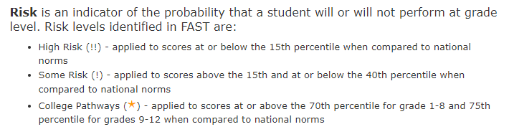
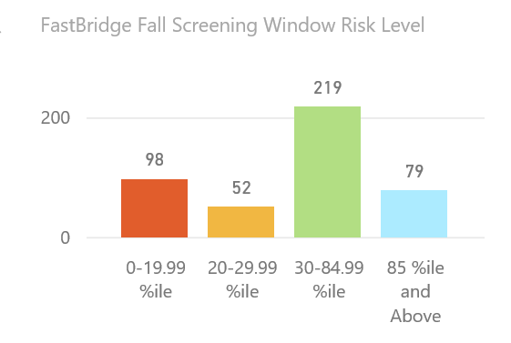

Display 1: This data reflects the percentage of ALL students performing in each band on the FastBridge Screening Assessment for English/Language Arts and reading. 21% or 98/448 of our students are at a High Risk of not performing at or above grade level on the reading portion of the Georgia Milestones Assessments.
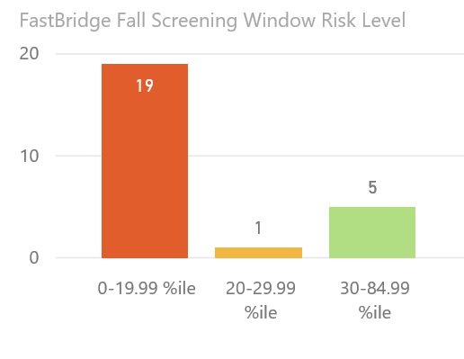

Display 2: This data reflects the percentage of Special Education students performing in each band on the FastBridge Screening Assessment for English/Language Arts and reading. 19/24 or 79% of our Special Education students are at a High Risk of not performing at or above grade level on the reading portion of the Georgia Milestones Assessments.

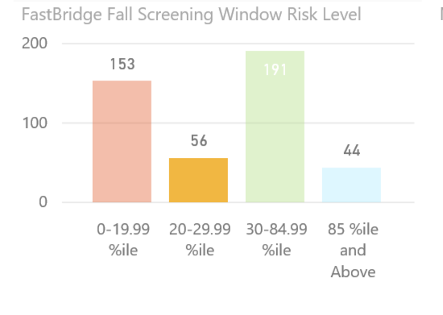
Display 3: This data reflects the percentage of ALL students performing in each band on the FastBridge Screening Assessment for mathematics. 34% of 153/444 of our students are at a High Risk of not performing at or above grade level on the math portion of the Georgia Milestones Assessments.
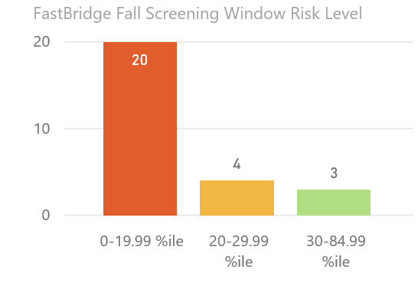
Display 4: This data reflects the percentage of Special Education students performing in each band on the FastBridge Screening Assessment for mathematics. 74% or 20/27 of our Special Education students at a High Risk of not performing at or above grade level on the math portion of the Georgia Milestones Assessments.

